ETF Entrepreneurship Award

Why an ETF Entrepreneurship Award?
How entrepreneurship is promoted through vocational education and training is acquiring increasing policy attention in the European Union set against efforts to build more competitive and employable economies. Entrepreneurship as a key competence, essential to building entrepreneurial mindsets and character of young people in particular, is the latest area of policy development. Given that the entrepreneurship key competence area is still developing, access to good practice provides teachers, curriculum specialists, training providers, as well as policymakers, with ideas and opportunities to develop their own work.

Through its work, the European Training Foundation (ETF) encourages its partner countries also to consider developing entrepreneurship key competence within vocational education and training; as well as to share their good practice. To this end, ETF is launching a call for good practice to identify good practice in entrepreneurship key competence promotion. The training provider selected for the best good practice will receive a dedicated award in recognition of their work that will be disseminated at a high-level EU meeting in Vienna in November 2018 as well as through ETF networks.

What is EntreComp?
EntreComp, the European Entrepreneurship Competence Framework, is made up of three competence areas: a) Ideas & Opportunities, b) Resources, and c) Into Action. Each of the areas comprises five competences that together constitute the building blocks of entrepreneurship as a competence. The framework develops the 15 competences along an 8-level life-long learning model. It also includes examples of learning outcomes for the competence areas. EntreComp can be used as a basis for the development of curricula and learning outcomes, as well as teaching and learning plans. It can also be used for assessment purposes of pupils and students (see annex 1 for more details).
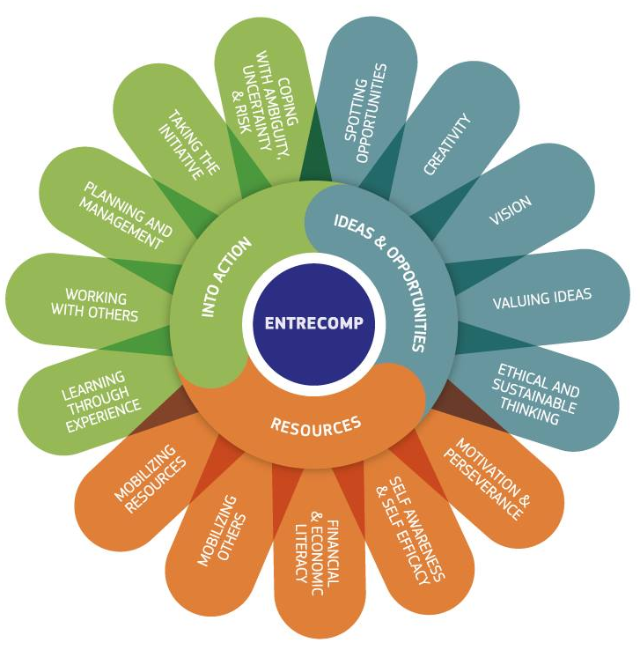

Who can participate?
The competition is open to all schools, universities and training centres (public or private) providing vocational education and training in ETF partner countries.

How to participate
Those wishing to submit a good practice should
- register for an ETF webinar where more detail on the call will be shared as well as to learn more about recent EntreComp developments (registration link), and
- complete the application form (ETF Good Practice platform)

Applications should be submitted in English via email by the deadline (22 May 2018) to EntreComp@etf.europa.eu.

Selection process
ETF staff and an expert representing 2017 ETF Entrepreneurship Award winning training provider will review all submissions against two criteria
- learning outcomes for the EntreComp competence areas and
- the teaching and learning approaches used in the practice.

The winner will be announced on 8 June 2018 on the ETF website.

Award ceremony
A representative of the training organisation selected for the ETF Entrepreneurship Award, and an education and training policy maker associated with the training provision, will be invited to Vienna, Austria, to participate in a conference to celebrate the 2018 European Vocational Skills Week.

The ETF Entrepreneurship Award will be conferred by Marianne Thyssen, European Commissioner for Employment, Social Affairs and Inclusion at the conference gala dinner on 8th November.

An information note on the winning good practice will be published and disseminated at the conference.
In addition, ETF will promote the good practice through its networks, good practice platform, social media and other publications. Please see privacy statement at Annex 2.

APPLICATION FORM

ETF Entrepreneurship Award

Are you a vocational school, university or training centre from an ETF partner country, providing vocational education and training?

Do you promote at least one of the competences in the EntreComp area “Ideas & Opportunities”?

Do you promote at least one of the competences in any of the two other EntreComp areas, “Resources” and “Into Action”?

If so, please submit your application via email to EntreComp@etf.europa.eu by 22 May 2018.

ETF Entrepreneurship Award
Please provide the required information below.

1. Details of participant and policy partner
Name
Address
Telephone
Email
Proposed conference participant | [or other staff member who will participate in European Vocational Skills Week and Gala Dinner]
Alternative participant | [Should the conference participant above not be able to join the conference and award ceremony in November, for whatever reason, an alternative participant from the will be invited]
Policy partner | [The winning submission will be invited to participate in the 2018 European Vocational Skills Week and the award ceremony in Vienna, Austria, together with an education and training policy maker associated with the good practice. After consulting with policymaker, please provide details of the policy official who will accompany the participant to Vienna]
 | Name:
 | Title:
 | Organisation:
 | Address:
 | Email:
 | Telephone:
Cooperation with business (optional) | [Please provide brief details on the role that businesses play in the good practice, if any.]

2. Entrepreneurship key competences ‘Ideas & Opportunities’
State the competences you promote which specifically reflect those falling under the EntreComp ‘Ideas & Opportunities’ competence area.

Provide an example(s) of a learning outcome(s) for the competence(s) chosen (max. 100 words)

Describe the teaching and learning approaches to achieve the learning outcome(s) (max. 200 words)

3. Entrepreneurship key competences ‘Resources’ and ‘Into Action’
State the competences you promote which specifically reflect those falling under EntreComp ‘Resources’ and/or ‘Into Action’ competence areas.

Provide an example(s) of a learning outcome(s) for the competence(s) chosen (max. 100 words)

Describe the teaching and learning approaches to achieve the learning outcome(s) (max. 200 words)

ANNEX 1 – Overview of EntreComp Competences
Competence Area | Competences
Ideas  and  opportunities | Spotting opportunities
 | Creativity
 | Vision
 | Valuing ideas
 | Ethical and sustainable thinking
Resources | Self-awareness and self-efficacy
 | Motivation and perseverance
 | Mobilising resources
 | Financial and economic literacy
 | Mobilising others
Into action | Taking the initiative
 | Planning and management
 | Coping with uncertainty, ambiguity and risk
 | Working with others
 | Learning through experience

Annex 2
PRIVACY STATEMENT FOR APPLICANTS PARTICIPATING IN THE CALL FOR GOOD PRACTICE
Context
The ETF is launching a call for good practice in entrepreneurial learning with the objective of selecting one or more training programmes that will be publicly shared as good practice in the field.
Within the framework of the call, all personal data processed are dealt with in compliance with Regulation (EC) No. 45/2001 of the European Parliament and of the Council of 18 December 2000 on the protection of individuals with regard to the processing of personal data by the Community institutions and bodies and on the free movement of such data, hereafter referred to as the Regulation.
In accordance with Articles 11 and 12 of the Regulation, the ETF hereby provides the following information on the processing.
Purpose of the processing
The purposes of the processing are:
- Logistics and administrative management of the call
- Sharing the data of the award-winning applicants both on paper publications and on a public web platform
Personal data
Personal data collected and further processed will be:
- Name and contact details (address, Email, telephone) of the person representing the participating vocational school or training centre, and the person representing the accompanying policy maker
The data is provided in the application form.
Provision of this data is on a voluntary basis. In the absence of this data, the general contact data of the training provider is used in the call.
Legal basis
The legal basis for the processing operations of personal data is:
- ETF’s mandate, article 1. Objective and scope, (b), article 2, functions, (f).
Controller identity
The Data Controller is the Director of the ETF.
Technical means of data processing
The data are processed both on paper and electronically.
Recipients of the personal data
For the purposes detailed above, the provided personal data is accessed by:
- The ETF team managing the call and one external reviewer administering the call on a need-to-know basis
- All members of the ETF good practice platform
- All public that receives a copy of the good practice information note (this is only the case for the award-winning applicants)
- The European Commission as organiser of the EU Vocational Skills Week 2018 (this is only the case for the award-winning applicants)
The ETF will not divulge personal data for direct marketing or commercial purposes.
Without prejudice to a possible transmission to the bodies in charge of a monitoring or inspection task in accordance with European Union and national law, certain personal data may be disclosed on a need-to-know basis to:
- ETF Legal Advisor,
- European Court of Justice or National judicial authority,
- The European Anti-Fraud Office (OLAF),
- European Ombudsman,
- European Data Protection Supervisor,
- European Court of Auditors and the Internal Audit Service.
Right of access, rectification, blocking, erasure
Any request to access, rectify, block or erase personal data shall be addressed in writing to the Data Controller, Director of the ETF: Mr Cesare Onestini, ceo@etf.europa.eu.
Time limits
All justified and legitimate requests will be carried out within one month of their reception.
Data retention
Data collected will be retained for 2 years following the completion of the call and the publication of the good practice on the ETF Good Practice Platform.
Contact information
Data processors in ETF are: Florian Kadletz (fka@etf.europa.eu) and Galyna Terzi (gte@etf.europa.eu).
Right of recourse
Data subjects can at any time have recourse to the ETF Data Protection Officer (dpo@etf.europa.eu), or to the European Data Protection Supervisor (http://www.edps.europa.eu) if they consider that their rights under Regulation 45/2001 have been infringed as a result of the processing of their personal data by the ETF.

Albania, Algeria, Belarus, Armenia, Azerbaijan, Bosnia and Herzegovina, Egypt, Georgia, Israel, Jordan, Kazakhstan, Kyrgyzstan, Libya, Kosovo*, Lebanon, former Yugoslav Republic of Macedonia, Moldova, Montenegro, Morocco, Palestine**, Russia, Serbia, Syria, Tajikistan, Tunisia, Turkey, Turkmenistan, Ukraine, Uzbekistan. * This designation is without prejudice to positions on status, and is in line with UNSCR 1244/1999 and the ICJ Opinion on the Kosovo declaration of independence. ** This designation shall not be construed as recognition of a State of Palestine and is without prejudice to the individual positions of the Member States on this issue.

